DATE: 02.11.2018
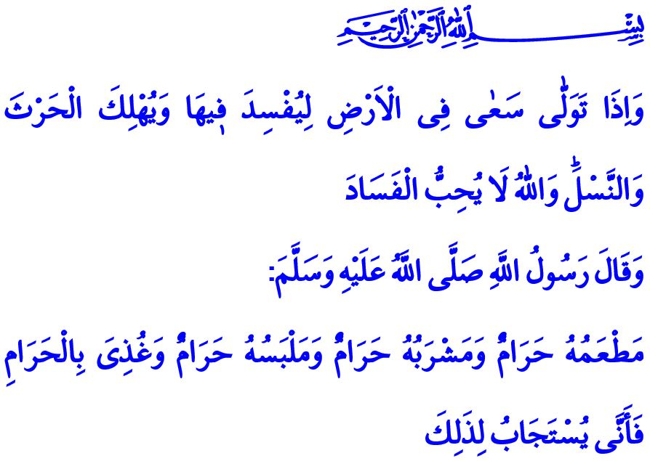
PURE FOOD, PURE GENERATION
Honorable Muslims!
One day the Messenger of Allah (saw) addressed all humankind, in presence of his Companions, “O people, Allah is pure and He therefore, accepts only that which is pure. And Allah commanded the believers as He commanded the Messengers...” He continued by reciting the following verse: “O messengers, eat from the good foods and do right. Indeed, I, of what you do, am Knowing.”
The Messenger of Allah (saw) then mentioned a person who had made long-distance travels, with his hair disheveled and his clothes covered with dust, he lifted his hand towards the sky (supplicating as): “O Lord, O Lord!”. Then our Prophet (saw) said: “Whereas his diet was unlawful, his drink was unlawful, and his clothes were unlawful, and his nourishment was unlawful. How could then his supplication be accepted?”
Esteemed Believers!
Allah, the Owner of the heavens and the earth, created a vast universe and a habitable world in it for humankind. He embellished it with sweet and pleasant waters, and countless kinds of delicious food. He bestowed us with the lands of crops, gardens of fruits, and the sun and rain to grow them. He gave, in service of humans, countless beings, each one of which is unique, beautiful and precious. Then, He commanded his servants to be selective by stating, “And eat of what Allah has provided for you [which is] lawful and good. And fear Allah, in Whom you are believers.”
Humankind, however, mostly took the way of mischief and harmed not only themselves but also the world, our home, instead of benefiting from the blessings of the Lord (swt) and beautifying the earth and reproducing goodness. Charmed by city life, luxury, and comfort, they have abandoned agricultural activities, the natural and balanced lifestyle. Modifying the genetics of seeds, and poisoning the nature with chemical and artificial products, they have spoiled the purest blessings. It was however, the duty of all of us to take care of our soils, crops, and hand labor.
Not heeding the divine warning, “That you not transgress within the balance.”, they have polluted the soil, the air, and the water, with their own hands. Lured into material benefits, they have forgotten the responsibility towards other beings and future generations despite the warning of Allah the Almighty (swt), “And cause not corruption upon the earth after its reformation…”
Esteemed Believers!
The material and spiritual destruction in a society begins with the genetic modification of food. Indifference to halal and haram contaminates people’s consciousness. When moral values and human values are not observed, the things that people eat, drink, produce and consume start to cause rather harm than benefit, which eventually leads to social degeneration, and corrupts the nature of young minds and generations. As a result, an environment emerges in which love, respect, and tolerance become extinct, and evil, impudence and injustice increase. As a matter of fact, the Lord Almighty (swt), referring to the hypocrites, states in the Holy Qur’an, “And when he goes away, he strives throughout the land to cause corruption therein and destroy crops and animals. And Allah does not like corruption.”. Therefore, those who want to destroy peace and order on earth strive to corrupt the crops and generations. The verse above is both a warning and an invitation for believers to produce clean foods and build a virtuous posterity.
Dear Muslims!
A deep effect has every word, every action, as well as every morsel, on our lives. We as human beings are responsible to watch what we eat and what we provide for our family and loved ones to eat. The world is entrusted to us, and we are entrusted to each other. Then, let us be aware of our responsibilities, and opt for a moderate and moral lifestyle. Let us pursue halal earning, clean production, balanced consumption, and healthy generations.

Mu’minun, 23/51.
Muslim, Zakat, 65; Tirmidhi, Tafsir al-Qur’an, 2.
Ma’idah, 5/88.
Rahman, 55/8.
A’raf, 7/56.
Baqarah, 2/205. General Directorate of Religious Services

